CIS/STA 3920, 7-15-20 Prof. L. Tatum

Lecture Notes 3: Mean Square Forecast Error

TABLE OF CONTENTS

Section Topic
1 Mean Square Forecast Error
2 Comparing MSFE for Different Lengths of Window
3 Writing Functions in R
4 The Coolest Functions, Ever
5 Exercises

Section 1: Mean Square Forecast Error

In data mining, we often compare several methods of forecasting future outcomes. We require a simple, quantitative measure of performance to help decide which method is prefereed. Consider the simple case of forecasting tomorrow’s high temperature. As we will soon see, such forecasts are seldom spot-on. For example, if the New York Times says that tomorrow’s high will be 58 degrees, it will seldom happen that the actual high temperature will also be 58: I kid you not! In statistics and in data mining, we keep track of these “forecast errors” and, among other tasks, employ them to help decide which forecasting method is best.
The difference between the forecast and the actual outcome is usually termed either an error or a residual, but in either case it is important to understand that these are not errors in the sense of “mistakes.” Here, “error” is a technical term and is not meant to imply criticism. Errors are an important part of learning.
Suppose we are comparing two forecasting methods, Method A and Method B. As a first thought, we might try taking the sum of the errors and picking the method with the smaller sum. However, that is not a good idea. Usually, about half the residuals will be positive and half negative, so the sum of the errors will be close to zero for both methods and little if anything will be learned by the comparison.
Our performance measure will be the sum of squared errors. The absolute value measure has some important usages in modern statistical methods, but squared deviations is far more commonly used because of its connection with the Pythagorean Theorem and distance measures.
Suppose, thought, that Method A and Method B do not have equal numbers of forecasts? Then, we need to take the average of the squared errors to remove the effect of the different sample sizes. We will denote this performance metric as the MSFE, for mean squared forecast error.
We will prefer the forecast method with the smaller MSFE.
Two more issues must be confronted. First, there is an element of chance in the MSFE we compute from any sample of events. Thus, it is possible that a forecast method which is actually better in the long run will by chance produce a higher (worse) MSFE in a given sample. So, we want be cautious and avoid jumping to conclusions. Sometimes we will emply hypothesis testing to guard against that.
A second problem is that there are many, many different forecasting methods that we could try. In fact, in data mining it is fair to say that the possible number of forecasting methods that could be tried are unlimited. In that situation, a very peculiar fact arises: when we try lots and lots of forecasting methods on the same data set, it is almost inevitable that the model with the smallest MSFE is a terrible model because trying tens of thousands of methods will force chance to dominate the selection process. In that setting, to rescue the MSFE criterion, we will use data-splitting to give us out-of-sample validation measures. This means that we set aside a large chunk of the available sample before we try any forecasting. Then, we pick out what seem to be our best methods based on forecasting from the working portion of the sample. Those most promising methods are then tested on the set-aside data! This sophisticated but readily grasped enhancement allows us to bring reliability to data mining. It puts the science into what is otherwise a dangerous enterprise.
In the material in this week, we will not be comparing lots of methods, so we can delay the application of data splitting techniques. Also, because of the time series nature of our sample data, data splitting is a little tricky to do. It may be that some of you will want to explore how to extend our results along those lines. That would be quite interesting and potentially of genuine interest in the field of Finance, but you will need to master the programming and conceptual concepts in this lecture note to be able to work successfully in that direction.

MSFE for High Temperature Forecasts

We are now going compare two methods of forecasting the next day’s high temperature for New York City, using as our sample data the period of time between December 2nd, 2006 and February 14th, 2007. The first method will be the forecast high temperature, as printed in the previous day’s New York Times. The second method will be to use the high temperature on the previous day. We will call this a “lag 1” forecast. (Data, graphs, and computations are in the accompanying Excel file.)
We anticipate that the professionally prepared forecasts will be better, but the point is to see how MSFE comparisons can be used to select a forecasting method. Also, today’s high temperature has quite a bit of information about tomorrow’s high because high temperature has a lot of “momentum.” No one will be surprised if tomorrow is cold when today is cold. What surprises us is when is tomorrow is warm and today was cold.
Here is a time series plot of the Actual and Forecast high temperature data, along with the Average high, which is estimated from historical data. I would not ordinarily connect up the data points with lines, but here it makes it easier to see how the Forecasts generally moved in anticipation with changes in the Actual.
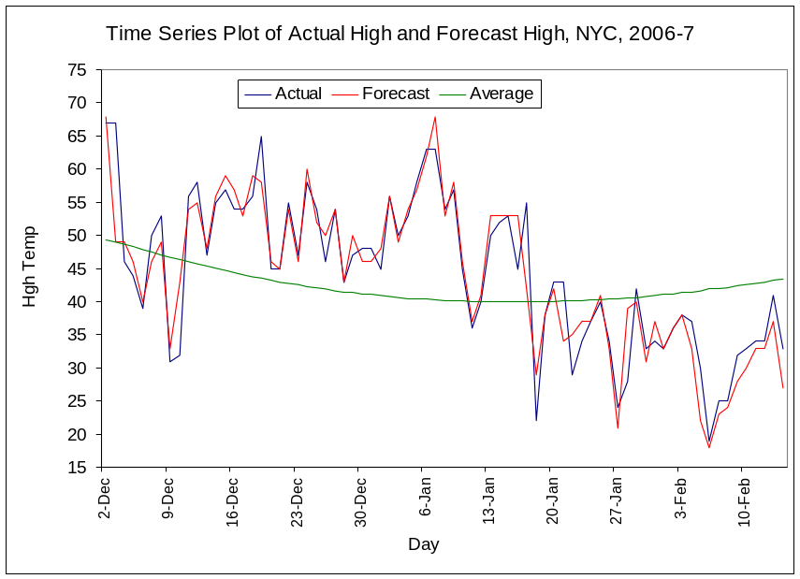

However, the agreement is not as good as we might initially think. The plot contains several surprisingly large forecast errors. These are best seen in Residual plot. On the left side, on December 3rd, there was a 19 degree forecast error! Errors like this happen when a warm front (or a cold front) arrives a little earlier or later than was forecast.
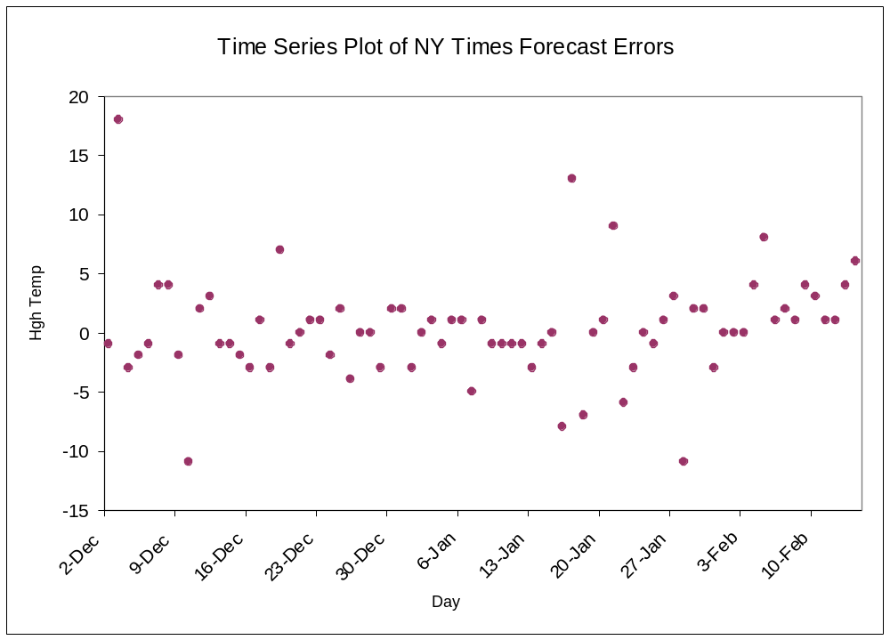

To compute the MSFE for the NY Times forecasts, we merely square those errors and take their average. This yields a MSFE of 18.7. It is hard to know what to make of that value because we have no benchmark against which to compare it. A metric like the MSFE is useful only if we another method and its MSFE to compare it against.
The MSFE for the Lag1 method (using the previous day’s high as forecast) is 83.3, which is substantially larger than for the NY Times professional forecast. Not surprisingly, the professional forecasts are declared the winner. (We could use a two-sample variance test to show the difference between the MSFE values is too large to be reasonably attributed to chance, but that is not our focus.)
It is also of interest to consider the historical Average high as a forecast as an exercise.

Section 2. Comparing MSFE for Different Lengths of Window

We are going to build a sophisticated MSFE function in R, but first we want to carefully construct a small example in Excel with which we can perform numerical checks of our R program. And, where you can carefully consider what we are about. These techniques are not self-explanatory: you have to work through them very carefully.
Suppose have a time series of with just five values. We are going to compare two forecasting methods: the Lag 1 method where the current value is used to forecast the next value; and Avg3 where a moving average of the three most recent values is used to forecast the next value. Note that both these forecasting methods are “honest” in that they do not include the value to be forecasted.
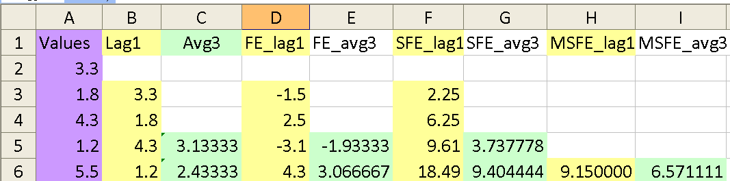

We have the five values in the time series in Column A. For the Lag1 forecasting method, we take the first observed value, 3.3, and consider it as the current value. This will be used to forecast the second value, which happened to be 1.8. In the Lag1 forecast column, Column B, in Row 3, we place our forecast of 3.3 alongside the target of 1.8. Placing the forecast alongside the target value helps keep everything tidy.
Now, we compute the error in that forecast,

error = actual-forecast = 1.8 – 3.3 = -1.5.

That error value of -1.5 has been placed in Row 3 of Column D, titled FE_lag1, which holds the forecast errors for the Lag1 method.
Continuing to focus on that row, we need to get the squared forecast error for that first Lag1 forecast. That is,

squared error = (actual – forecast)^2 = (-1.5)^2 = 2.25.

This value, 2.25, is placed in Column F, titled SFE_lag1, where SFE stands for Squared Forecast Error.
We can now use the fill handle to copy those commands down in Columns B, D, and F. That will yield the four squared forecast errors for Lag1 in Column F. The mean of the values in Column F is computed and placed in the sixth row of Column H, titled MSFE_lag1, and it equals 9.150000. That looks like too many decimal places, but you want a lot of digits to compare when checking a program.
The moving average forecast needs three days of data before it can get started, whereupon it takes the average of those three values and uses that to forecast the fourth value, which happened to be 1.2 in A5. We want to put that forecast in Row 5, Column C, titled Avg3. In Cell C5, we type
=average(A2:A4)

and get 3.13333. This forecast yield a forecast error of

1.2 – 3.13333 = -1.93333,
which is entered in Cell E5.
Continuing on, we get an MSFE of 6.57111for Avg3, the moving average with window width 3. This value is less than that for Lag1, but that means nothing special, here. We are just creating a reference set to use to test our R program.
And, we are learning what it is we are about. Don’t skip this Excel worksheet. Set aside some time and try to recreate it from just the first column. It is harder than one might think. And, in the process of making small errors and fixing them, you will learn a lot.

Section 3. Writing Functions in R

We will start by writing a simple function in R. Let’s make a function that returns the first value of a vector. A vector is a sequence of values. Let’s call this program GiveMeFirst.
There several ways to prepare and edit functions in R. Here is a good one, using the “fix” editor, which is designed to work on functions.

Step 1. In R, type

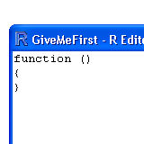
> fix(GiveMeFirst)

That opens an edit window with the skeleton of an R function, which consists of the word “function” followed by “()”, which is where the arguments to the function will go, and then a pair of curly brackets in which the operations will occur.

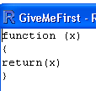
Step 2. The best way to work is to make one change at a time to a program, but also change the output of the program to see if the intended change was in fact made. Our first change will be to put an x between the parentheses in the first row. Then, we make a second change to see if the first worked: we add the statement return(x) between the curly brackets. It is our intention that is we supply this function with a value or a vector, it will return that value to us, unchanged.

Step 3. Close and save the function. Create a little vector, say,

> x = c(3.4, 2.7)

Now, let’s input that into the function GiveMeFirst:

> GiveMeFirst(x)
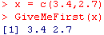
and hit Enter. Hopefully, this will give you x.

In my case, it worked. If your function did not work, then you have made a mistake somewhere above. That will narrow down you search for the error. This could be in a typing failure when calling the function – did you get the capital letters in the right place in “GiveMeFirst”? Was x defined? Did you save while exiting the fix editor? Did you remember to put an x in both places in the program? Did you spell return as Return or as return? Watch out because R is case sensitive.
Anticipate that you will make mistakes and try not to be surprised by them. Never program in a hurry.

Step 4. Let’s make another single change in the program, assuming you have gotten this far. Type
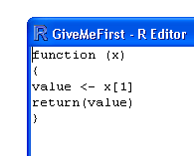
fix(GiveMeFirst)
to open the function for editing. Insert this line within the curly brackets and before the return(x) line:
value = x[1]

To see if this was done properly, put the name value into the return command:

return(value)

Close the editor and save.

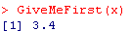
Step 5. Try the new version on the same x:

> GiveMeFirst(x)

Did this work correctly? In my case, yes, because it gave me the first element of the vector x.
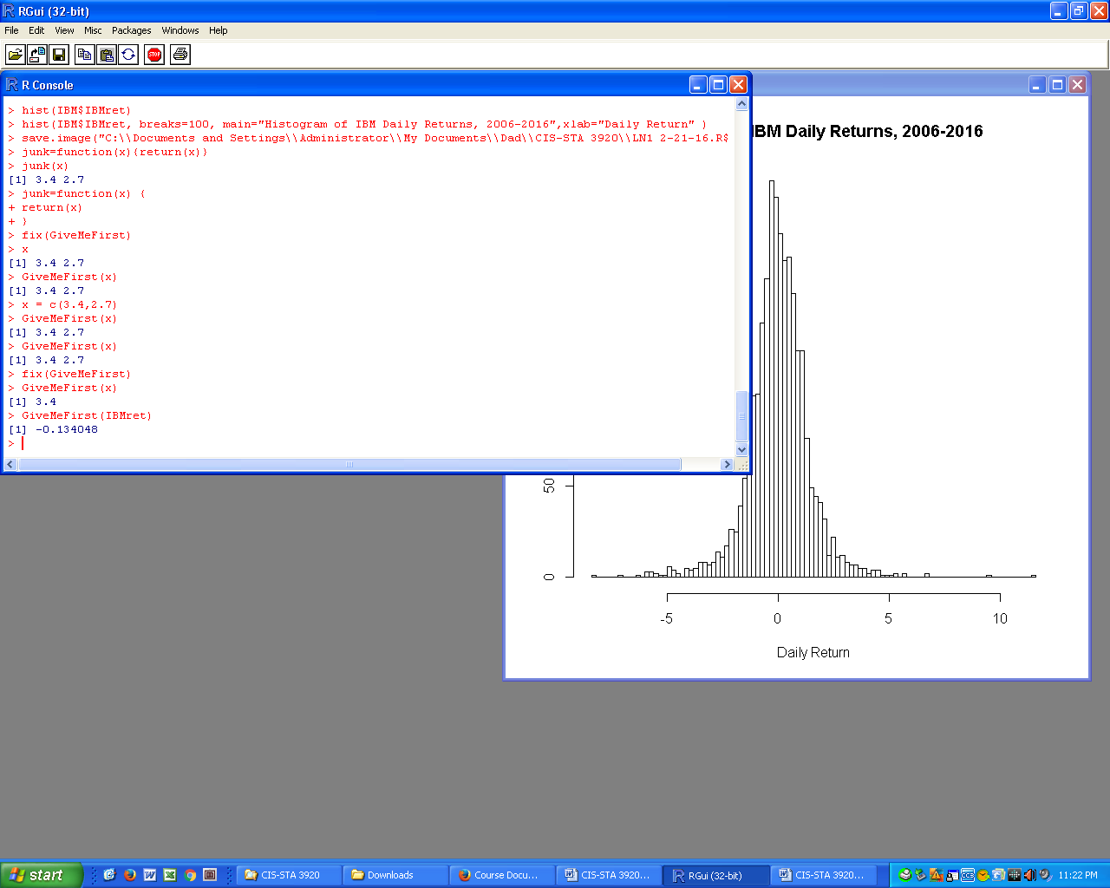
Step 6. Give the function a challenge, like IBMret.
Recall IBMret = IBM$IBMret.

which is in fact the first value of that vector.

Two small points: first, the initial value in the returns is often missing and in that case this function will return NA. (Try to remember to delete the first row in that case.) So, know ahead of time the first value in the vector you are testing this on. Second, it is very easy to make a mistake, which is why we should work in small steps. For example, while writing this up, I happened to capitalize “Return” and R would not run the function. If I had made a lot of changes to a working program and made that mistake, it might take a long time to find it.

Copying an R Function

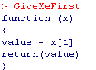
Try typing in just the function name and hitting Enter. You get back the function content, as shown.

Let’s see if we can copy and paste directly from R into Microsoft Word. Yes, that worked. Notice I did not bring the R prompt, >, with me. If you did, delete it.

GiveMeFirst
function (x)
{
value = x[1]
return(value)
}

Now, let’s see if we can copy and paste that function back into R and get it to work.

Step 1. We don’t want to overwrite our own copy of GiveMeFirst, so let’s give this a new name, say, GiveMe. I have made that edit, below.

GiveMe
function (x)
{
value = x[1]
return(value)
}

Step 2. We have to use an assignment to connect GiveMe and the rest of the function. Insert an equals sign after GiveMe, or the <- assignment symbol.

GiveMe =
function (x)
{
value = x[1]
return(value)
}
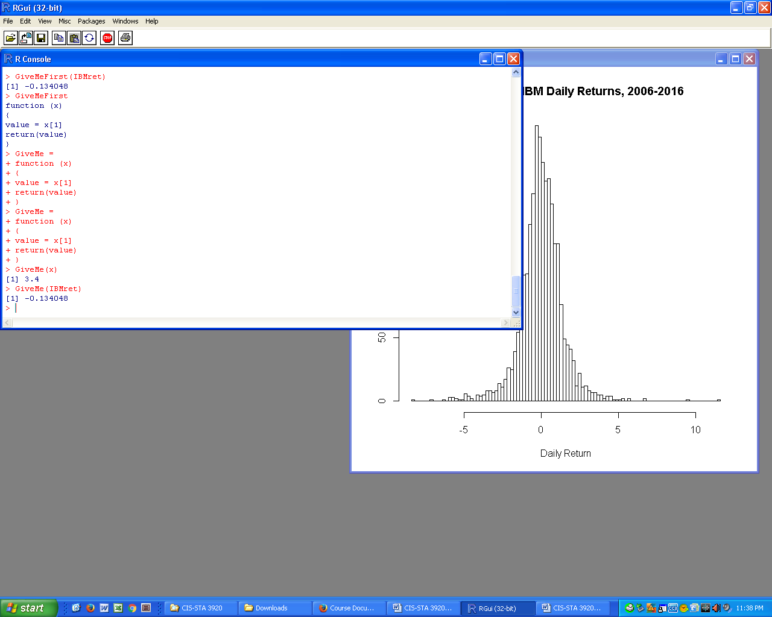
Step 3. Copy and paste that into R, alongside an R prompt.
It doesn’t matter if your original text is black or in bold font; R will turn it red, like shown to the right.

Step 4. Try out GiveMe on that x vector and on the IBMret. With luck, it will work. Without luck, you have a good idea where to look for the problem because we are doing one thing at a time!

Step 5. Take a break and do a little dance. You have accomplished several important and non-trivial tasks, recently. First, you have written an R function that runs. Second, you can in principle copy and paste in R functions from Word documents. You are ready to take on the World!

Writing Loops

There are some people who hold that loops should be avoided at all costs in R. If you meet people like that, give them full respect because it may be that you can learn a great deal from them. But, in the meantime, there are many circumstances in which loops are worth doing. Let the loop-haters stew! As I understand it, loops in R are actually run in C++, a language in which loops are run with a very high level of efficiency. When you avoid a loop in R, ultimately the program must still use a loop, behind the scenes. So, let’s loop.

Here is a first loop program. To start, examine it and try to guess what it will do.
Then, copy and paste it into R. Run for some value of n.

FirstLoop
function (n)
{
y=rep(NA,4)
for(i in 1:4)
{
y[i] = i**2
}
return(y)
}
Now, alter the function so it uses “n” instead of 4.

A Standardization Loop
Create the following function in R.
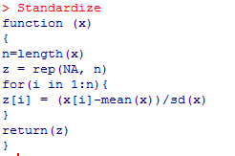

Section 4. The Coolest Functions Ever

The following R programs are relatively simple and yet extremely powerful. The first program computes the mean square forecast error, MFSE, for a moving average forecast of a given window length. I named it MVG1. To get it into R, copy and paste the following block of code to the R command prompt. This kind of copying from Word works most of the time, but can fail when quotation marks are involved – then, you have retype the quotation marks within R.

MVG1 =
function (x,m)
{
n <- length(x)
y <- vector(length=(n-m))

for(k in 1:(n-m)) {
y[k] <- ( x[m+k] - mean(x[k:(k+m-1) ]) )**2
}
msfe <- mean(y)
return(msfe)
}

That function takes two arguments: first, x is the vector of values, second, m is the length of the moving average window. To make sure this is working properly, create a vector which matches the values used earlier in our little Excel MSFE test kit, as follows:

z = c(3.3, 1.8, 4.3, 1.2, 5.5)

Now, try this:

MVG1( z, 1)

which returns 9.15.

Go to the Excel worksheet and see if you can find 9.15. Aha! That is the value of the Mean Square Forecast Error for the Lag1 method. (This reminds us that the Lag1 method can also be considered a moving average forecast with window width equal to 1.)

Now, in Excel, note that the MSFE was 6.57111 for the moving average forecaster with window length equal to 3. Let’s see if our R program matches that.

MVG1( z, 3)

Yes, that works!

This shows that our MVG1 program is working correctly, assuming our Excel work was correct. (Or, at least they match!)

Putting One Function Inside Another

Next, we want to put that MSFE program into a larger program that will find the MSFE for all window lengths from 1 to a specified integer value. That integer value is denoted “d” in the program. Copy the following text and paste into R.

VSFE <-
function (x,d) # x is data, d is max window length
{
z <- vector(length=d)
for(j in 1:d) {

z[j] <- MVG1(x,j)

}
return(z)
}

Recalling that 4 was longest window we could use for a moving average forecaster when the data set was only 5 values, I tried this:

> VSFE(z,4)
[1] 9.150000 4.682500 6.571111 8.122500

In the output, you will the MSFE for Lag1 in the first position and that of Avg3 in the third position. What are the other two values? They are the MSFE for methods Avg2 and Avg4, which we did not compute in Excel.
I strongly urge you to go back to Excel and compute the MSFE for Avg2 and Avg4 to check the above values. I doubt you will find that an easy exercise, but the effort it takes will pay immensely in the form of insight and of understanding of what we are about.

Coolest Program Ever

Let’s try VSFE on my IBM return data, going out to window width 500. Remember to assign the command to a name. For trial purposes, I often recycle common names, like y, so my Workspace does not get full of data sets which I have forgotten. For purposes of a project, though, you want to give special names and write down all important details of your work in a notebook, including the dates. That is, if you ever want to find the output, again.

y <- VSFE( IBMret, 500)

That may take a little while to run, depending on your computer.

Now, print out the first 5 values:

y[1:5]

That returns these values:

3.968640 2.952826 2.579931 2.445100 2.378513

of which the first is the MSFE for Lag1, the second is the MFSE for a moving average forecast of length 2, and so on.

Now, let’s plot y.

plot(y, type="l")

or, to make it clearer,

plot(y, type="l", main="IBMret MFSE for MovAvg Forecasts, d=1:500", xlab="Window Length")
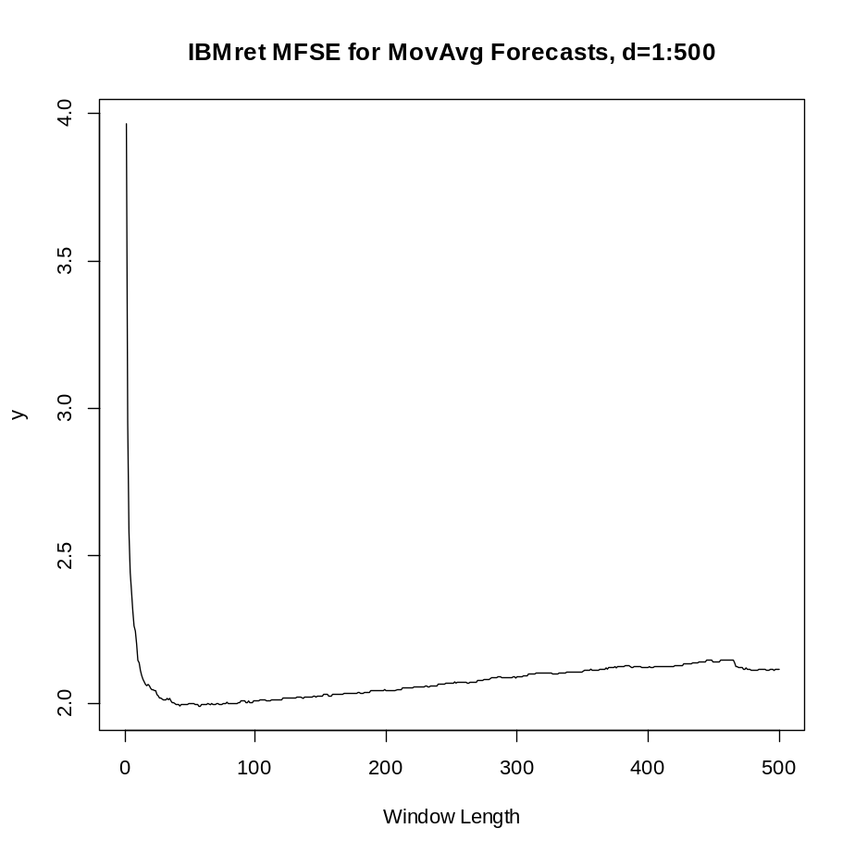

Overall, what this suggests that the best choice for the length of a moving average forecast for the next day’s return on IBM is around 35 to 40, because that is where the MSFE is minimized. We should exercise some caution, though, because we know the time span of the IBM returns used contained the dramatic events of 2008 and these may have colored this result. I would certainly want to run this for the post 2008 period and see if the results are similar.
In the enormous Grasberg Mine in Papua, New Guinea, what do they mine, or extract? They extract gold and copper. What have we mined, here, from this IBMret data? We extracted information about the optimal length for a moving average forecast of IBM daily returns.
There is a world of implications, illustrations, lessons, and challenges for Finance and Statistics in this graph. Most importantly for us will be this: why does the graph come down and then go up? The answer is that there is a bias-variance trade-off at work. We will investigate that issue in the following weeks.
Why does the graph go down again at around window length of 450? That is a vexing question. I cannot promise we will be able to come to grips with it in this course. As soon as we get (a) good tools with which to work and (b) good theory to guide our pick and shovel and (c) high quality data, we will find things that nobody yet understands.

Lecture Notes 3. Exercises

1. Copy and paste both the MSFE and VSFE programs from pages 11 and 12 into the same R file with your stock data. Run the function VSFE on your stock Return, going out to window length of 500.
(a) Plot the first 100 MSFE values, y[1:100]. Put a title on the graph that states the company name and helps a reader identify what has been done.
(b) In the plot, circle one data point – any point you like – and explain what the horizontal and vertical coordinate values for that point represent. This will be a very difficult task if you do not understand the output of the function.
(c) What window length would you recommend if using a moving average for this stock? Why?
(d) Plot, again, but with all 500 MSFE values. Compare your plot to mine for IBM. What differences do you see?
(e) People often think that the market follows trends and has “momentum” for which tomorrow’s return will tend to more closely resemble today’s return more than a return from a week ago. If momentum like that exists, should the MSFE for a window of length 1 be smaller or larger than for a window of length 10? Why?

2. Try VSFE for your Closing Prices. Show the graph. What do you learn about forecasting stock prices?

3. Compute the daily Range for your stock by subtracting the Low column from the High. Run VSFE on your Range data to get the mean square forecast error out to moving average lengths 100. What looks to be the best choice of the moving average length for forecasting daily range? Why?

4. Extra Credit Write your own original R function containing a loop. Explain what it does on each line and what the function does, overall.

